The John Armstrong Award for Transport Archives 2019

The Motorway Archive Trust Collection
Glamorgan Archives

Introduction

Professor John Armstrong was one of the most significant transport historians of his generation. Professor of Business History at Thames Valley University, his interests ranged across transport history, including railways, urban buses and road transport, but his specialism was the study of coastal shipping, on which he published several notable works.

A founding member of the Transport History Group in the 1970s, he convened the British Commission for Maritime History’s highly respected seminar series, and for over a decade was Editor of the Journal of Transport History. He was valued supporter of the Business Archives Council, serving both as Honorary Editor and, later, as Honorary Treasurer.

The John Armstrong Award is a special, one-off cataloguing grant for £4,000 jointly funded by a bequest from the late John Armstrong and the Business Archives Council, for the cataloguing of transport-related business archives.

The aims of the Award are to:
- Provide financial support for institutions/businesses that manage transport-related business archives
- Reach transport-related collections that have not yet been prioritised but have potential academic or socio-historical value
- Create opportunities for archivists or para-professionals/volunteers to gain experience in listing transport-related business collections
- Make more transport-related business collections accessible

Glamorgan Archives is honoured to have received the John Armstrong Award to fund the cataloguing of the Motorway Archive Trust collection for Wales.

The Motorway Archive Trust

The Motorway Archive Trust was established in 1999 with the aim of advancing public education by acquiring and making available at local and national repositories archives relating to the creation of the British motorway network. The Trust developed from the suggestion of Sir Peter Baldwin, Permanent Secretary of the Department of Transport, that an archive relating to the motorway achievement in the UK should be created by those involved in the work, in order to safeguard the records for present and future research. In Wales, a Regional Committee was formed to carry forward this work, leading to the publication of the book ‘The Motorway Achievement. Building the Network in Wales' (2010) by Brian Hawker and Howard Stevens. The Trust has produced publications and educational packages, and collected archive material, depending heavily on the work of about 200 volunteers. The Motorway Archive Trust was wound up as a charity in December 2014 with responsibilities transferred to the Institution of Civil Engineers and the Chartered Institution of Highways & Transportation.

The Road Network in Wales

A road connecting London and south Wales was first proposed during the 1930s as a response to the economic depression at that time. The plan for the M4 motorway was approved in 1956 as one of the first major road improvements in post-war Britain. The Welsh section was finally completed in 1993, with the second Severn Crossing added in 1996. The A55 North Wales Expressway connects Chester to Holyhead and has developed during the period from the 1930s onwards.

Transport, and especially road transport, is an area often overlooked by historians. But the M4 motorway, leading to the Severn Crossing, and the A55 expressway in north Wales, are key to the history, economy and politics of the Welsh nation. The routes link Wales to the rest of Britain but are also distinctly Welsh – exemplified by the Severn Crossing which marks the boundary of the Welsh and English sections of the M4. The development of these roadways is bound in with the history of Welsh politics and devolution, reflecting the relationship between government in London and the Welsh Office in Cardiff.

The development of the road network in Wales reflects economic change, with the move from heavy industry, the products of which were transported by rail, to a manufacturing industry more reliant on road transport, and the creation of commuter belts around the roadways. These roads had an enormous impact on major towns such as Cardiff and Newport, now by-passed by the road, and Port Talbot – bisected by the M4. The impact was felt in the valleys beyond the roadways, with resentment building towards the M4 and A55 corridors seen as drawing economic investment to the detriment of the areas beyond, and through the transformation of small communities into commuter towns. The developments illustrate the strong east/west links across north and south Wales but the lack of internal transport links between the north and south.

The Motorway Archive Trust Collection at Glamorgan Archives

The Motorway Archive Trust made three large deposits of records to Glamorgan Archives from 2010-2016. Our collection records the development of the M4 motorway across south Wales, the Severn Crossing, and A55 'North Wales Expressway', along with several trunk roads. The 30 boxes of records date from 1939-2010 and comprise minutes, correspondence, reports, contracts, photographs, plans and background papers to the publication of ‘The Motorway Achievement: Building the Network in Wales’.

The initial deposit of records received in 2010 was catalogued. The aim of this project was to catalogue the remaining records deposited in 2012 and 2016 to item level, thus updating and expanding the existing catalogue description and ensuring the accessibility of the collection in its entirety.

The Cataloguing Process

Cataloguing was undertaken by Lowis Lovell, a recently qualified Archivist who had previously worked as a Records Assistant and Intern at Glamorgan Archives. This was her first major cataloguing project post-qualification, undertaken with support and guidance from the professional team of five archivists at Glamorgan Archives. The project was overseen by Rhian Diggins, Senior Archivist at Glamorgan Archives.

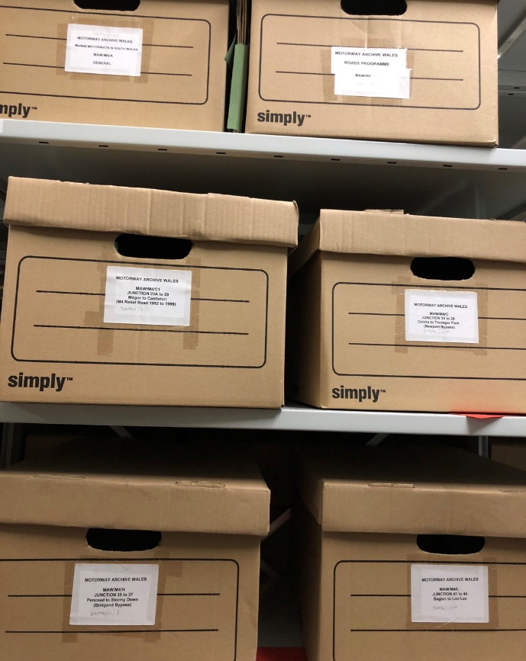
An initial scope of the material highlighted that the collection was very disjointed. A small but detailed catalogue existed for part of the collection. Later unlisted accessions were scattered across the strong rooms, including the bulk of the material - a recently deposited collection of twelve bankers’ boxes. Creating box lists for the uncatalogued material provided a greater insight into the content and format of the unlisted records.

The bulk of the uncatalogued material focused on the making of the M4 Motorway and consisted of detailed records of the construction of the motorway section by section. This was a relief somewhat, as the small catalogued part of the collection focused on administrative records of the Motorway Archive Trust, removing any immediate issue of slotting the unlisted material into the existing catalogue. The records were in separate folders or boxes according to the part of the motorway to which they related, and this set the foundation for the catalogue structure at series level. Sixteen series entries on the completed catalogue are based on junctions, with two other series based on the making of the first and second Severn Crossing.

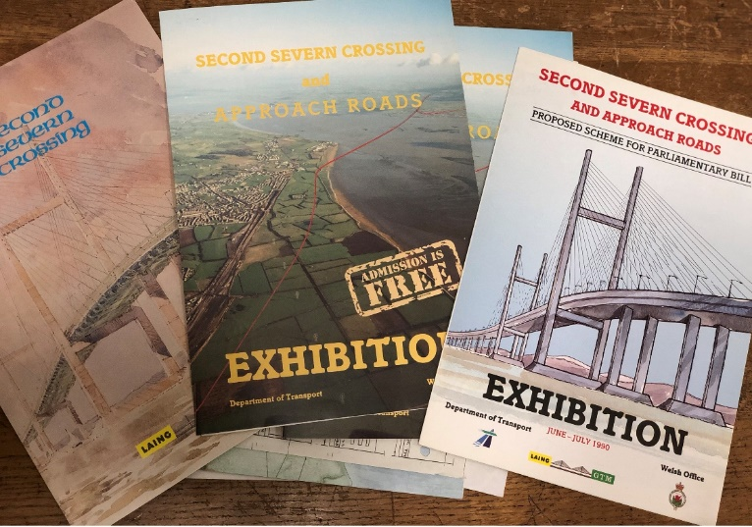
The remainder of the unlisted material comprised brochures, leaflets, papers and booklets relating to existing bodies, including The Welsh Office, Ministry of Transport, and the Institution of Civil Engineers.

Several series of records included both English and Welsh language material and have therefore been catalogued bilingually to reflect this, in line with Glamorgan Archives cataloguing policy.

The administrative records that had to be added to the pre-existing catalogue related to the Motorway Archive Wales and their publications, and were easily inserted into the catalogue. Papers, articles and background material relating to their published works ‘The Motorway Achievement. Building the Network in Wales' (2010) and ‘The M4 in South Wales’ form a significant part of this collection.

During the cataloguing process the records were repackaged in archive quality acid-free packaging. Advice was sought from the Conservation Team at Glamorgan Archives on the housing and labelling of photographic material, in particular the slide collection.

The catalogue is now complete. It has been added to the National Archives’ Discovery catalogue and is available to the public to view through the Glamorgan Archives catalogue, Canfod:

http://calmview.cardiff.gov.uk/Record.aspx?src=CalmView.Catalog&id=DMAW&pos=1

What next for the Motorway Archive Trust collection?

The completion of this catalogue provides transport, construction and engineering enthusiasts with an exciting new collection to explore. The making of the M4 motorway was a pivotal moment in Welsh history; it allowed travel throughout South Wales to become easier and more fluid; it created thousands of jobs for the Welsh workforce as well as more employment opportunities, as the Severn crossings provided a direct link between England and Wales.

The Motorway Trust Collection contains documents that reflect the history of the road network in Wales outlined above, and which illustrate the impact of key roadway infrastructure, with great research potential for historians of the politics, economy and culture of Wales and its people. Academic research on the M4 to date is limited. We believe that once the records are catalogued work on this neglected area of Welsh history will be promoted and advanced.

We also believe that, now it is fully accessible, it will be of interest to the general population living within the areas of Wales impacted by roadway development. When used in conjunction with other significant collections of records such as those of the coal, steel and manufacturing industries, it could be used to enhance a sense of community identity and pride, and encourage engagement with Glamorgan Archives.

In addition, the collection includes engineering records evidencing the huge task facing those charged with constructing these roadways through often difficult terrain. This material could potentially be used to explore the environmental impact of the developments.

The collection will be promoted via the Glamorgan Archives blog. Currently the blog is celebrating the 80th anniversary of Glamorgan Archives, with a series of articles focussing on each decade since we opened in 1939. The Motorway Archive Trust collection features for the 1970’s, a busy period of construction on key motorway junctions in Glamorgan, with 1977 seeing the most completed roadworks during the entire making of the M4; a total of 31 miles in eight months at a cost of £130 million. This work is documented in the records which form the collection.
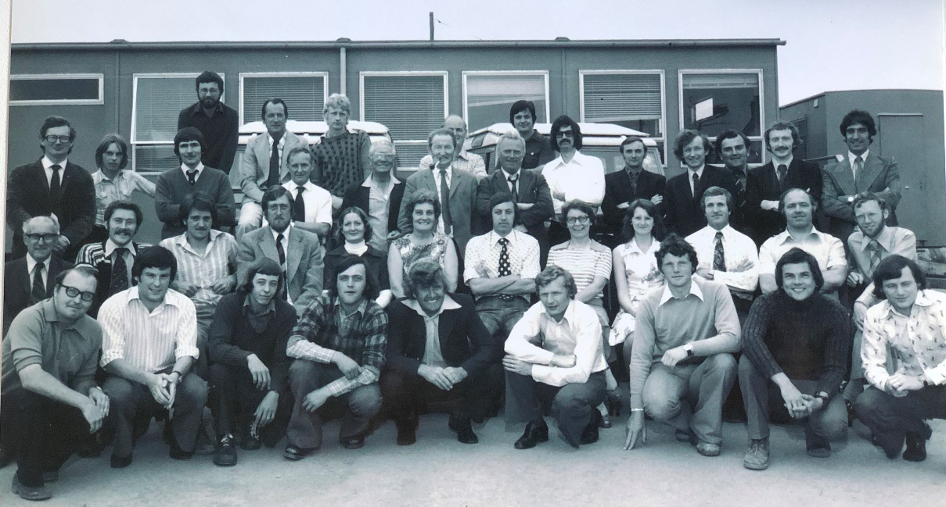

Construction of Margam to Stormy Down Junction, staff photograph, 1970’s (DMAW/14/7/2)

Further blog posts are planned to continue promotion of the collection.

A press release will be issued to celebrate the conclusion of the project, to highlight material within the collection, and to raise awareness of its accessibility to researchers at Glamorgan Archives.

Posts on social media have highlighted work being undertaken on the project, with cross-promotion through the Institution of Civil Engineers. A series of posts have been planned for the coming months to showcase items within the collection.

